✅ Types of Numerical Quantifiers
# Source: AI Source: Provided by: [Data Path: Persons Table -> ID Column: 1, Name_En Column: Motasem Essam] -> From: [ChatGPT] on [7/28/2025]
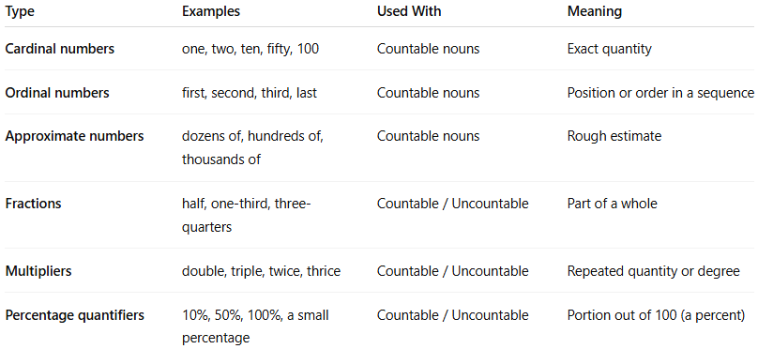

Type | Examples | Used With | Meaning
Cardinal numbers | one, two, ten, fifty, 100 | Countable nouns | Exact quantity
Ordinal numbers | first, second, third, last | Countable nouns | Position or order in a sequence
Approximate numbers | dozens of, hundreds of, thousands of | Countable nouns | Rough estimate
Fractions | half, one-third, three-quarters | Countable / Uncountable | Part of a whole
Multipliers | double, triple, twice, thrice | Countable / Uncountable | Repeated quantity or degree
Percentage quantifiers | 10%, 50%, 100%, a small percentage | Countable / Uncountable | Portion out of 100 (a percent)

